CODE
<!DOCTYPE html>
<html>

<head>
<title>My School Timetable</title>
<style>
body {
background-color: floralwhite;
font-family: sans-serif;
line-height: 1.6;
text-align: center;
}

blockquote {
background-color: bisque;
border-left: 5px solid black;
padding: 15px;
font-style: italic;
color: black;
}

table {
background-color: blanchedalmond;
width: 100%;
border-collapse: collapse;
}

th,
td {
padding: 10px;
text-align: center;
border: 1px solid burlywood;
}
</style>
</head>

<body>
<h1>Welcome to <br><u>PONVIDYASHRAM GROUP OF SENIOR SECONDARY SCHOOLS</u></h1>

<h2>Our Vision</h2>
<blockquote>
"We envision to impart Holistic Education for the Development of Future Leaders of this Nation through Efficient
and Smart Team of Teachers."
</blockquote>

<h2>Useful Learning Links</h2>
<ul>
<li><a href="https://wikipedia.org" target="_blank">Online Encyclopedia</a></li>
<li><a href="https://www.codingal.com/student/dashboard/" target="_blank">Coding Practice Portal</a></li>

<h2>Morning School Routine</h2>
<ol>
<li>Arrive at campus via van and complete discipline checks.</li>
s
<li>Read the daily newspaper.</li>
<li>Regular classes begin.</li>
</ol>

<h2>PV School Features</h2>
<ul>
<li>Co-curricular activities include student council, sports teams, math clubs, talent shows, spelling bees,
writing competitions, and debates.</li>
<li>Extra activities like Cricket, Volley Ball, Badminton, Kho-Kho, Athletics, Chess, Fine Arts like Music,
Dancing, Painting, and Yoga.</li>
</ul>

<h2>Subject Descriptions</h2>
<dl>
<dt>Maths & Life Skills</dt>
<dd>Building strong numerical foundational skills alongside critical empathy modules and real-world
problem-solving methods.</dd>

<dt>Physics, Chemistry & Biology</dt>
<dd>Exploring the rules of nature, core chemical equations, and anatomy inside our biology lab.</dd>

<dt>Computer Science & Robotics</dt>
<dd>Learning logic systems, programming foundational blocks, and configuring automated hardware kits.</dd>

<dt>Languages</dt>
<dd>Strengthening global communication and local culture appreciation across English, Tamil, and Hindi.</dd>

<dt>Creative Arts</dt>
<dd>Enhancing physical flexibility, rhythm mastery, and tactile expression in Western Dance, Yoga, and Art &
Craft.</dd>

<dt>Social Studies & Library</dt>
<dd>Analyzing historic global events alongside quiet reading segments focused on textbook research development.
</dd>
</dl>

<h2>Weekly Timetable (08:30 AM - 03:40 PM)</h2>
<table border="1">
<tr style="background-color: darkkhaki;">
<th>Time Slot / Period</th>
<th>Monday</th>
<th>Tuesday</th>
<th>Wednesday</th>
<th>Thursday</th>
<th>Friday</th>
<th>Saturday</th>
</tr>
<tr>
<td>08:30 AM - 09:00 AM</td>
<td>Assembly</td>
<td>Assembly</td>
<td>Assembly</td>
<td>Assembly</td>
<td>Assembly</td>
<td>Assembly</td>
</tr>
<tr>
<td>09:00 AM - 09:40 AM (Period 1)</td>
<td>Maths</td>
<td>English</td>
<td>Biology</td>
<td>Computer Science</td>
<td>Physics</td>
<td>Maths</td>
</tr>
<tr>
<td>09:40 AM - 10:20 AM (Period 2)</td>
<td>Hindi</td>
<td>Life Skills</td>
<td>Tamil</td>
<td>Western Dance</td>
<td>Art and Craft</td>
<td>Social</td>
</tr>
<tr>
<td>10:20 AM - 10:30 AM</td>
<td>Snack Break</td>
<td>Snack Break</td>
<td>Snack Break</td>
<td>Snack Break</td>
<td>Snack Break</td>
<td>Snack Break</td>
</tr>
<tr>
<td>10:30 AM - 11:10 AM (Period 3)</td>
<td>Library</td>
<td>Biology Lab</td>
<td>Chemistry</td>
<td>Yoga</td>
<td>Robotics</td>
<td>Library</td>
</tr>
<tr>
<td>11:10 AM - 11:50 AM (Period 4)</td>
<td>Social</td>
<td>Maths</td>
<td>Maths</td>
<td>English</td>
<td>Biology</td>
<td>English</td>
</tr>
<tr>
<td>11:50 AM - 12:30 PM (Period 5)</td>
<td>Computer Science</td>
<td>Physics</td>
<td>Hindi</td>
<td>Life Skills</td>
<td>Tamil</td>
<td>Tamil</td>
</tr>
<tr>
<td>12:30 PM - 01:00 PM</td>
<td>Lunch Break</td>
<td>Lunch Break</td>
<td>Lunch Break</td>
<td>Lunch Break</td>
<td>Lunch Break</td>
<td>Dismissal</td>
</tr>
<tr>
<td>01:00 PM - 01:40 PM (Period 6)</td>
<td>Western Dance</td>
<td>Art and Craft</td>
<td>Library</td>
<td>Biology Lab</td>
<td>Chemistry</td>
<td>Home</td>
</tr>
<tr>
<td>01:40 PM - 02:20 PM (Period 7)</td>
<td>Yoga</td>
<td>Robotics</td>
<td>Social</td>
<td>Maths</td>
<td>Maths</td>
<td>Home</td>
</tr>
<tr>
<td>02:20 PM - 02:30 PM</td>
<td>Snack Break</td>
<td>Snack Break</td>
<td>Snack Break</td>
<td>Snack Break</td>
<td>Snack Break</td>
<td>Home</td>
</tr>
<tr>
<td>02:30 PM - 03:10 PM (Period 8)</td>
<td>Physics</td>
<td>Chemistry</td>
<td>Computer Science</td>
<td>Robotics</td>
<td>English</td>
<td>Home</td>
</tr>
<tr>
<td>03:10 PM - 03:40 PM (Period 9)</td>
<td>Maths</td>
<td>Biology</td>
<td>Tamil</td>
<td>Hindi</td>
<td>Life Skills</td>
<td>Home</td>
</tr>
</table>

<h2>Favourite Activities Table</h2>
<table border="1">
<tr style="background-color: darkkhaki;">
<th>Subject Name</th>
<th>Location / Room</th>
<th>Estimated Duration</th>
<th>Why it is a Favourite</th>
</tr>
<tr>
<td>Robotics</td>
<td>Main Robotics Lab</td>
<td>40 Minutes</td>
<td>We get to assemble smart components and program mechanical companion systems.</td>
</tr>
<tr>
<td>Western Dance</td>
<td>Fine Arts Studio</td>
<td>40 Minutes</td>
<td>Learning complex contemporary team steps provides a great physical workout.</td>
</tr>
<tr>
<td>Yoga</td>
<td>Asana Meditation Hall</td>
<td>40 Minutes</td>
<td>It centers our breathing, relaxes muscles, and expands body alignment focus.</td>
</tr>
</table>

<h2>Student Testimonials</h2>
<p>
<q>The management is very good</q> said a student from class 4.
</p>
<p>
<q>Teachers make me understand the cincepts very well</q> said a student from class 7.
</p>
<small>Disclaimer: The given information is for informational purposes only</small>
</body>

</html>
OUTPUT
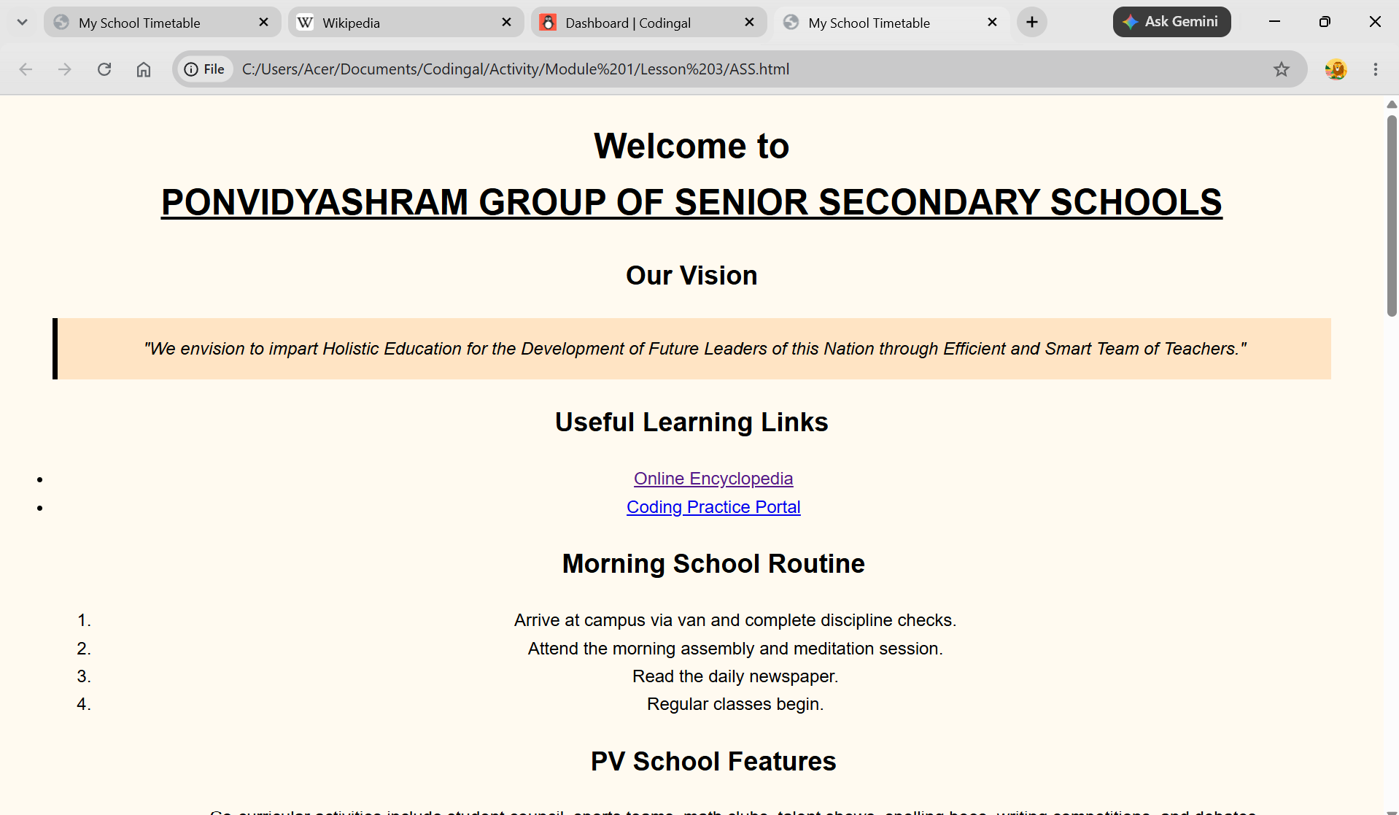
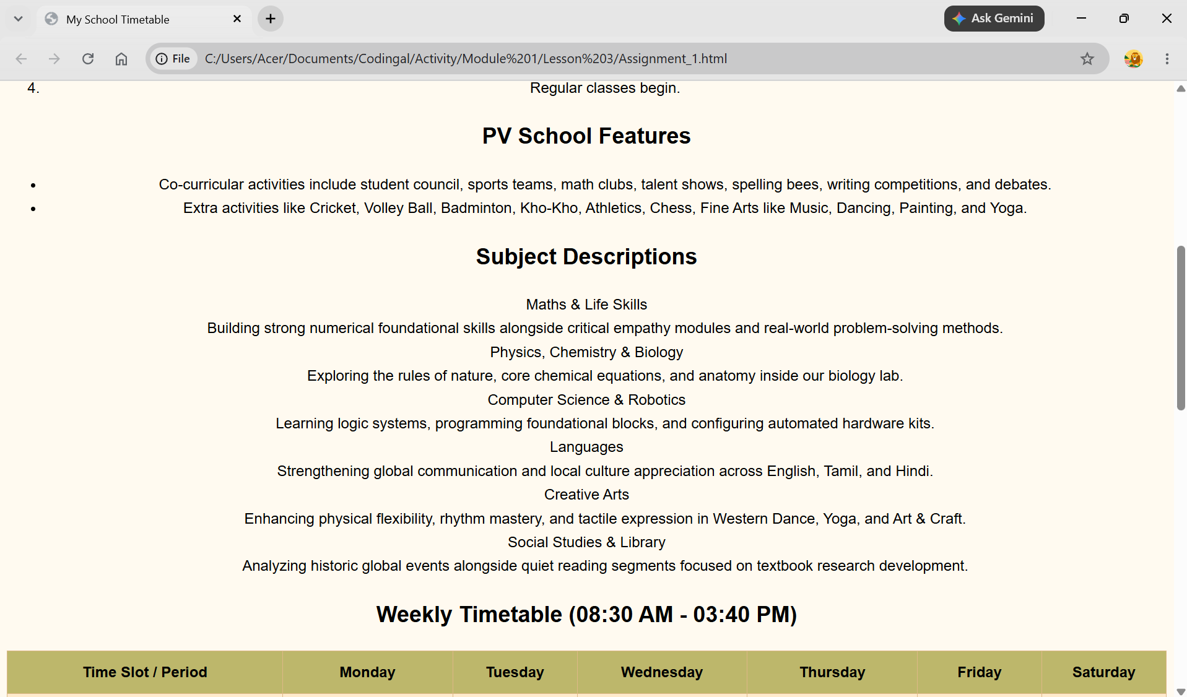
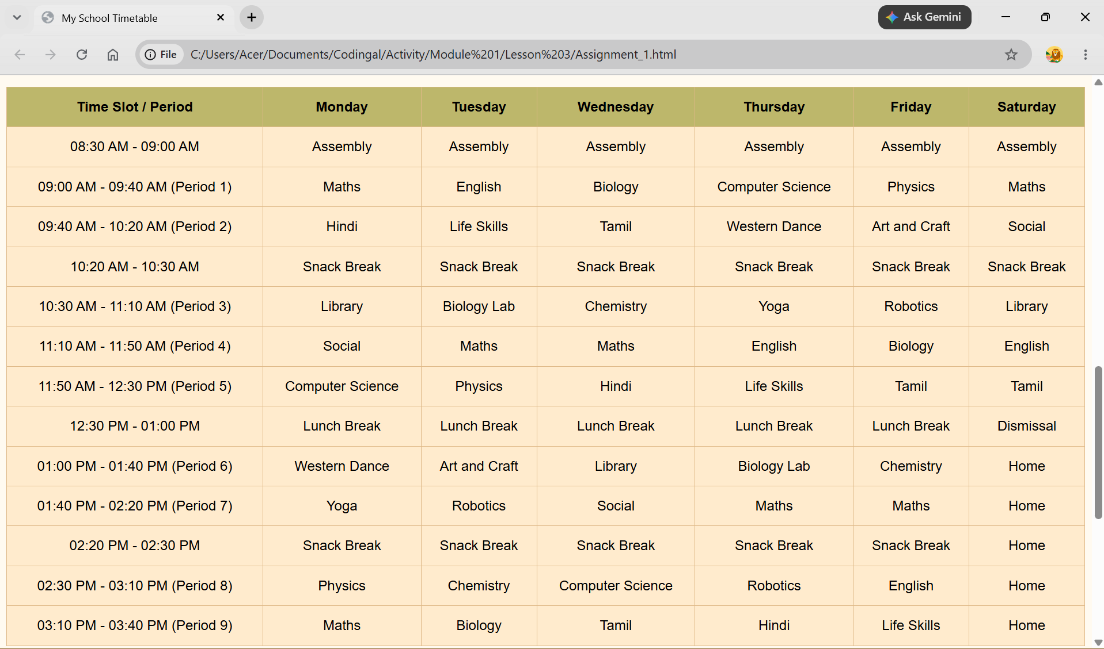
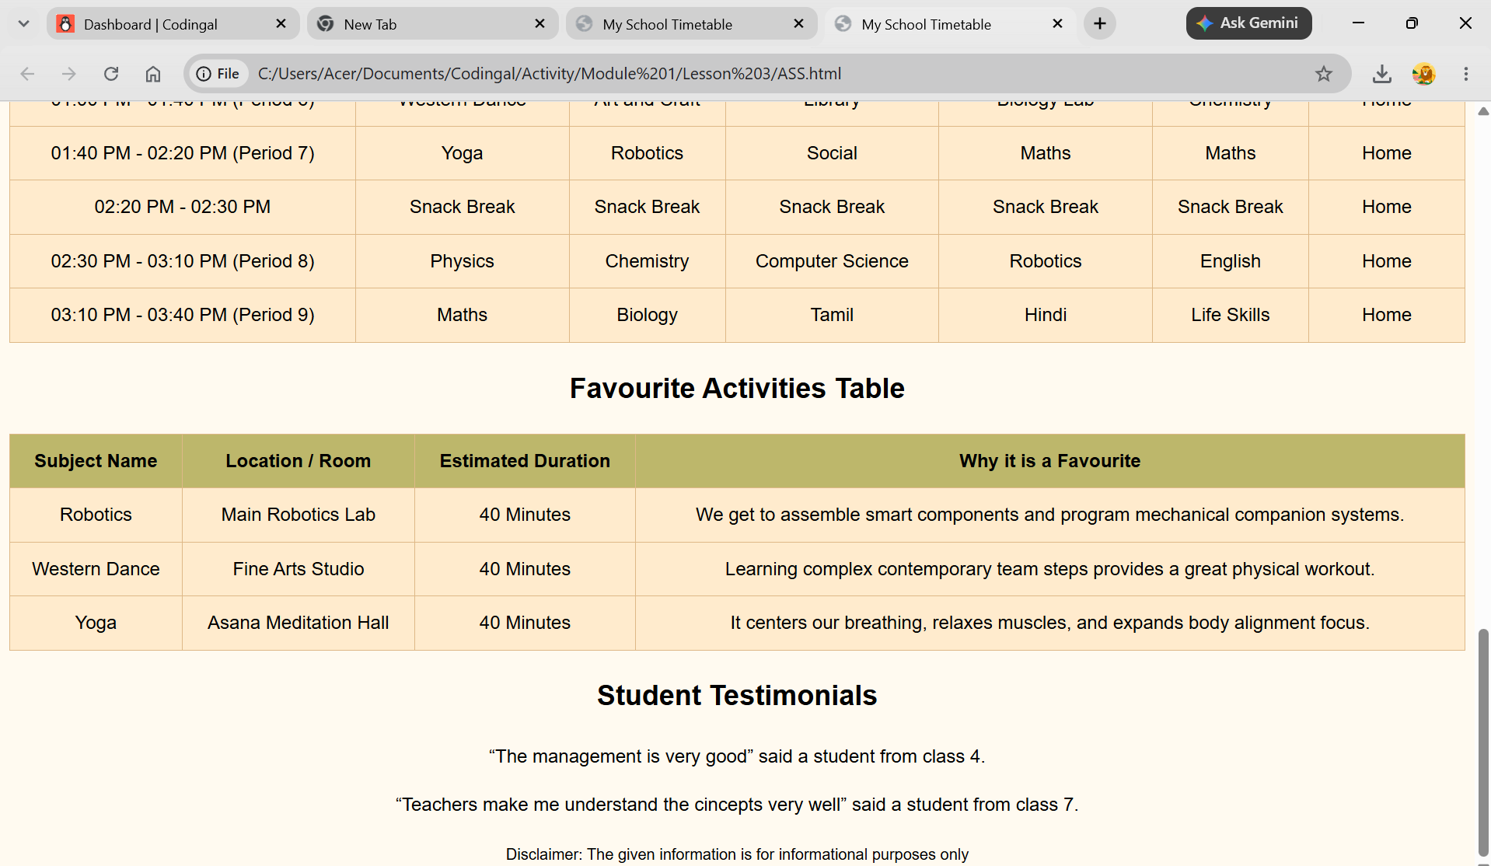
HYPERLINKS
https://www.wikipedia.org/
https://www.codingal.com/student/dashboard/

